**ROSHNI RAZA**

**LAB NO : 07**

**SAP ID : 61278**

**TASK 1:**

#include <iostream>

using namespace std;

#define Max 3

int top = -1;

int s_arr[Max];

void Pop(){

if (top == -1){

cout<<" stack underflow"<<endl;

return;

}

int value = s_arr[top];

cout<<"pop value :"<<value<<" ";

top--;

cout<<endl;

}

void Push(int data)

{

if (top == Max - 1){

cout << "stack overflow" << endl;

return;

}

top++;

s_arr[top] = data;

cout << s_arr[top] << " ";

}

void peek() {

cout << "Top element: " << s_arr[top];

}

void display() {

if (top == -1) {

cout << "stack is empty";

return;

}

cout << "Current stack elements: ";

for (int i = 0; i <= top; i++) {

cout << s_arr[i] << " "; }

}

int main() {

Push(1);

Push(2);

Push(3);

Push(4);

display();

cout << endl;

peek();

cout << endl;

Pop();

Pop();

Pop();

Pop();

return 0;

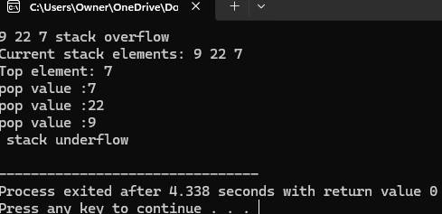

**TASK 2:**

#include <iostream>

using namespace std;

struct Node

{

string item;

Node* next;

};

Node* head = NULL;

void AddItem(string data) {

Node* newNode = new Node();

newNode->item = data;

newNode->next = NULL;

if (head == NULL)

{

head = newNode;

}

else

{

Node* temp = head;

while (temp->next != NULL)

{

temp = temp->next;

}

temp->next = newNode;

}

cout << "Added: " << data << " ";

}

void RemoveItem(string data)

{

Node* temp = head;

Node* prev = NULL;

while (temp != NULL && temp->item != data)

{

prev = temp;

temp = temp->next;

}

if (temp == NULL)

{

cout << "Item not found";

return;

}

if (prev == NULL)

{

head = temp->next;

}

else

{

prev->next = temp->next;

}

delete temp;

cout << "Removed: " << data << " ";

}

void ViewList()

{

if (head == NULL)

{

cout << "List is empty";

return;

}

cout << "Grocery list: ";

Node* temp = head;

while (temp != NULL)

{

cout << temp->item << " ";

temp = temp->next;

}

}

int main()

{

AddItem("Milk");

AddItem("Bread");

AddItem("Eggs");

ViewList();

cout << endl;

RemoveItem("Bread");

ViewList();

return 0; }

